Crowd Simulation Software

User Guideline

# Contents

1. **Graphical User Interface 10**
   1. Environment Editor 10
      1. Workspace Control 10
         1. Panning 10
         2. Zoom In/Out 10
      2. Menu 10
      3. Toolbox 12
      4. Simulation Parameters 13
      5. Scene Objects 14
   2. Run Simulation 15
      1. Export Data 15
      2. Export Image Sequence 15
      3. Export Video 15
   3. Optimizer 16
      1. Simulation Parameters 16
      2. Optimizer Settings 16
      3. Simulation Environment 16
      4. Running Optimizer 17

# Graphical User Interface

## 1.1. Environment Editor

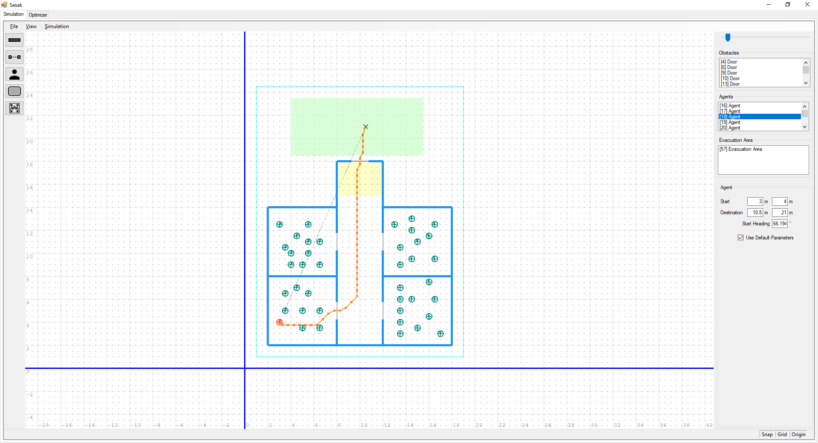

### 1.1.1. Workspace Control

#### 1.1.1.1. Panning

Hold right click & drag to pan.

#### 1.1.1.2. Zoom In/Out

Mouse scroll up to zoom in. Mouse scroll down to zoom out.

### 1.1.2. Menu

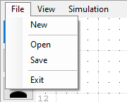

#### [File] > [New]

Create new scene.

#### [File] > [Open]

Open scene from file.

#### [File] > [Save]

Save scene to file.

#### [Exit]

Exit application.

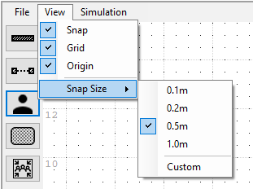

#### [View] > [Snap]

Enable / disable object snapping.

#### [View] > [Grid]

Show / hide grid.

#### [View] > [Origin]

Show / hide origin line.

#### [View] > [Snap Size]

Set snap size

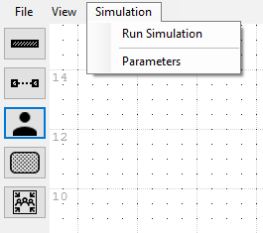

#### [Simulation] > [Run Simulation]

Run simulation with current scene.

#### [Simulation] > [Parameters]

Show simulation parameters dialog.

### 1.1.3. Toolbox

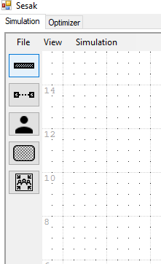

**1. Add New Wall**

**2. Add New Door**

**3. Add New Agent**

**4. Define Comfort Zone**

**5. Add Evacuation Area**

#### Add New Wall

Create new wall, wall can be either vertical or horizontal. Click & drag in workspace to draw wall.

#### Add New Door

Create new door, door can be either vertical or horizontal. Click & drag in workspace to draw door.

#### Add New Agent

Create new agent. Click & drag in workspace to define agent starting position & destination.

#### Define Comfort Zone

Define comfort zone. Click & drag in workspace to define comfort zone. Comfort zone is used to compute discomfort. Average crowd vs Density & Flow vs Density plot also computed using comfort zone.

#### Add Evacuation Area

Create new evacuation area. Click & drag in workspace to create new evacuation area. In simulation, agents entered evacuation area are marked as evacuated.

#### Cancel Draw Action

Press **[ESC]** key to cancel draw action.



Snap, grid & origin can be quick toggle at the bottom right.

### 1.1.4. Simulation Parameters

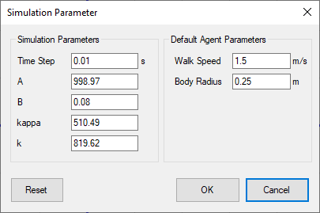

Configure simulation parameters. Simulation parameters can be access by clicking Simulation > Parameters on the menu.

### 1.1.5. Scene objects

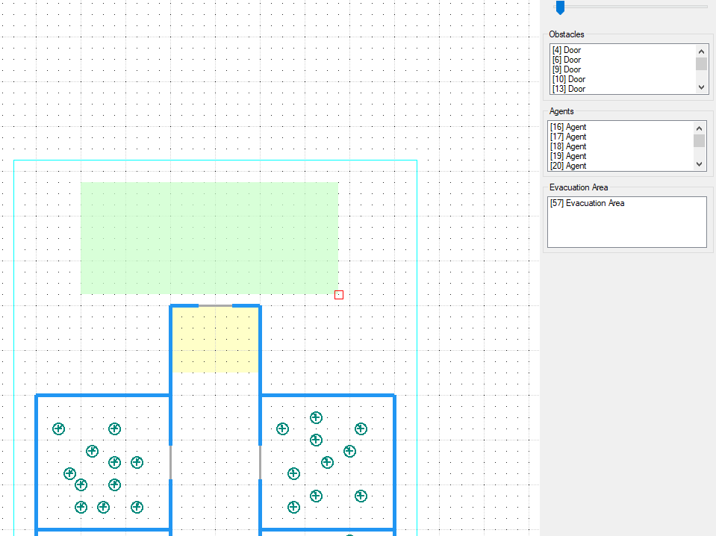

**Viewport Scale**

**Obstacles (Door & Wall)**

**Evacuation Areas**

**Agents**

Doors, obstacles, agents, and evacuation areas can be selected using lists on the right side.

#### Delete Object

To delete object, select object in the list and press **[Delete]**.

## 1.2. Run Simulation

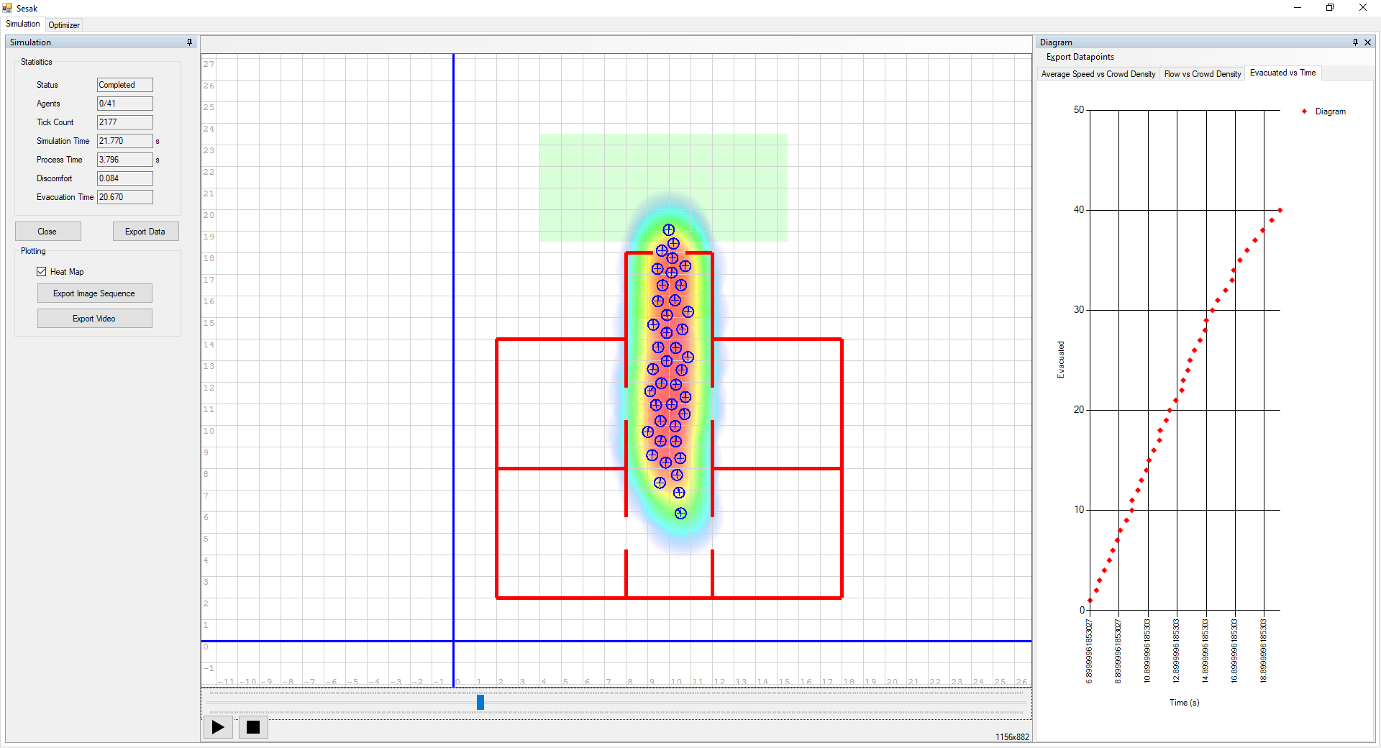

**Viewport**

**Playback Control**

**Simulation Result**

**Fundamental Diagram**

### Close

Close simulation run & back to scene editor

### Heat Map

Show / hide heatmap.

### 1.2.1. Export Data

Export current simulation data to CSV file.

### 1.2.2. Export Image Sequence

Export image sequence of simulation playback. Image sequence output use current viewport position & size.

### 1.2.3 Export Video

Export video of simulation playback. Video output use current viewport position & size. Exporting video require ffmpeg. Download ffmpeg at <https://ffmpeg.org/>

## 1.3. Optimizer

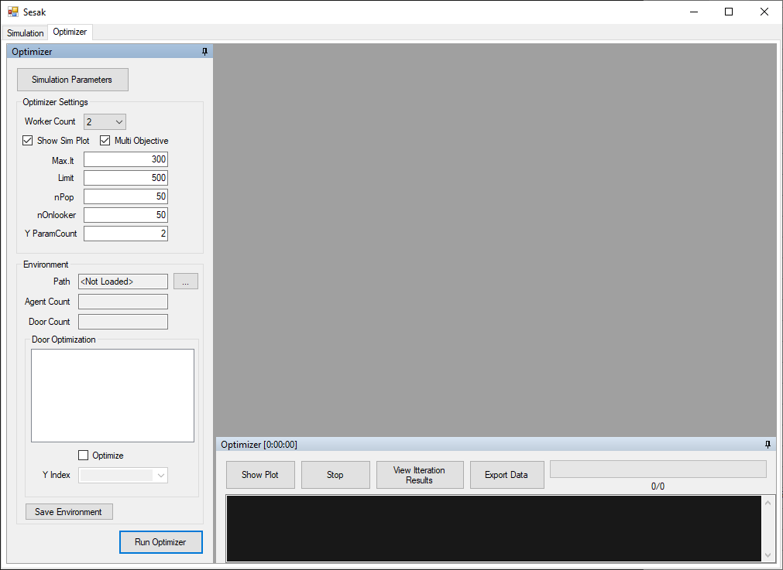

### 1.3.1. Simulation Parameters

Show simulation parameters dialog.

### 1.3.2. Optimizer Settings

#### Worker count

Define maximum simulation instance for optimizer.

#### Show Sim Plot

Show simulation plots during optimizer run. *This will slow down optimizer calculation.

### 1.3.3. Simulation Environment

#### Path

Load scene from file to run optimizer.

#### Door optimization

Define which door need to optimize.

#### Y Index

Define door group. Door with same group will share position value. Group count is defined in

Y ParamCount in Optimizer Settings.

### 1.3.4. Running Optimizer

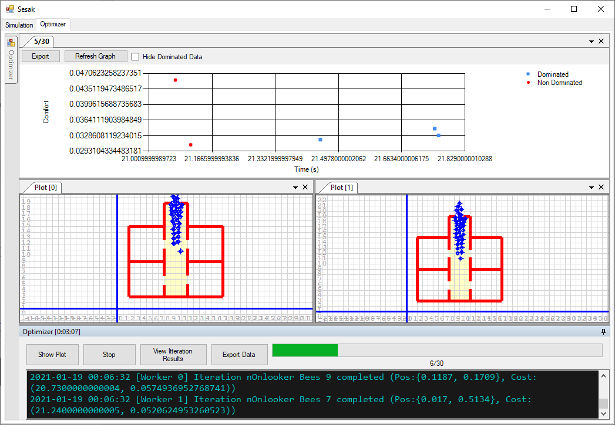

In multi-objective, dominated & non dominated result are shown on the chart. Double click on the data point to show result & scene details.

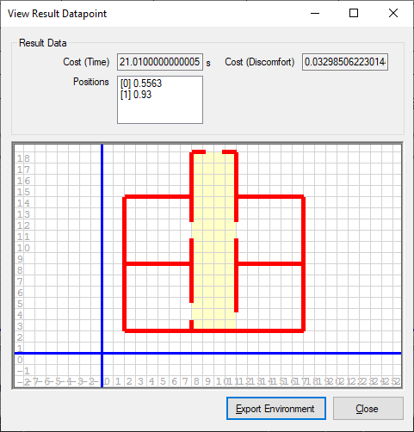

#### Export Environment

Save current scene to file.